COE 457

IoT

HW3

Mohammad Kharoof

73865

Due date: 12/3/2020

When a user isn’t signed in:

Registration:

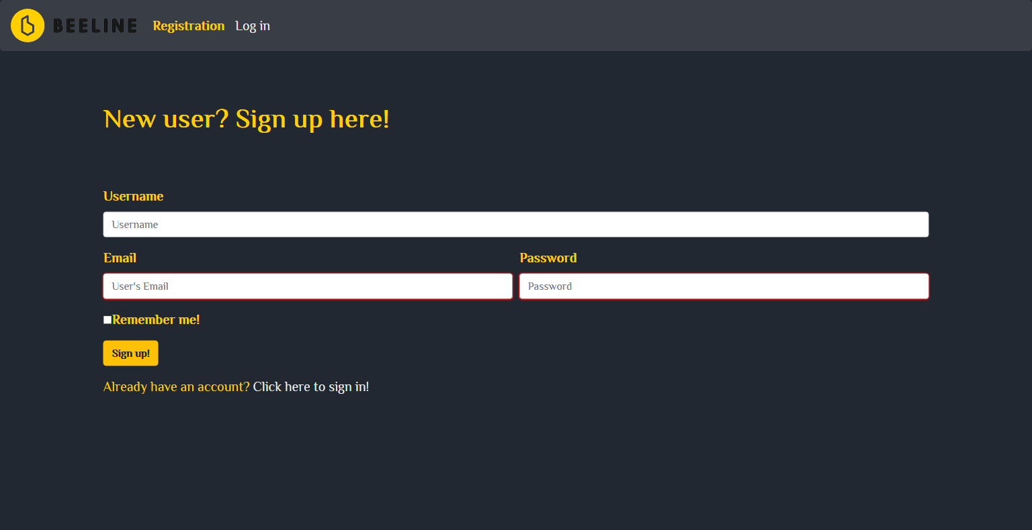

Login:

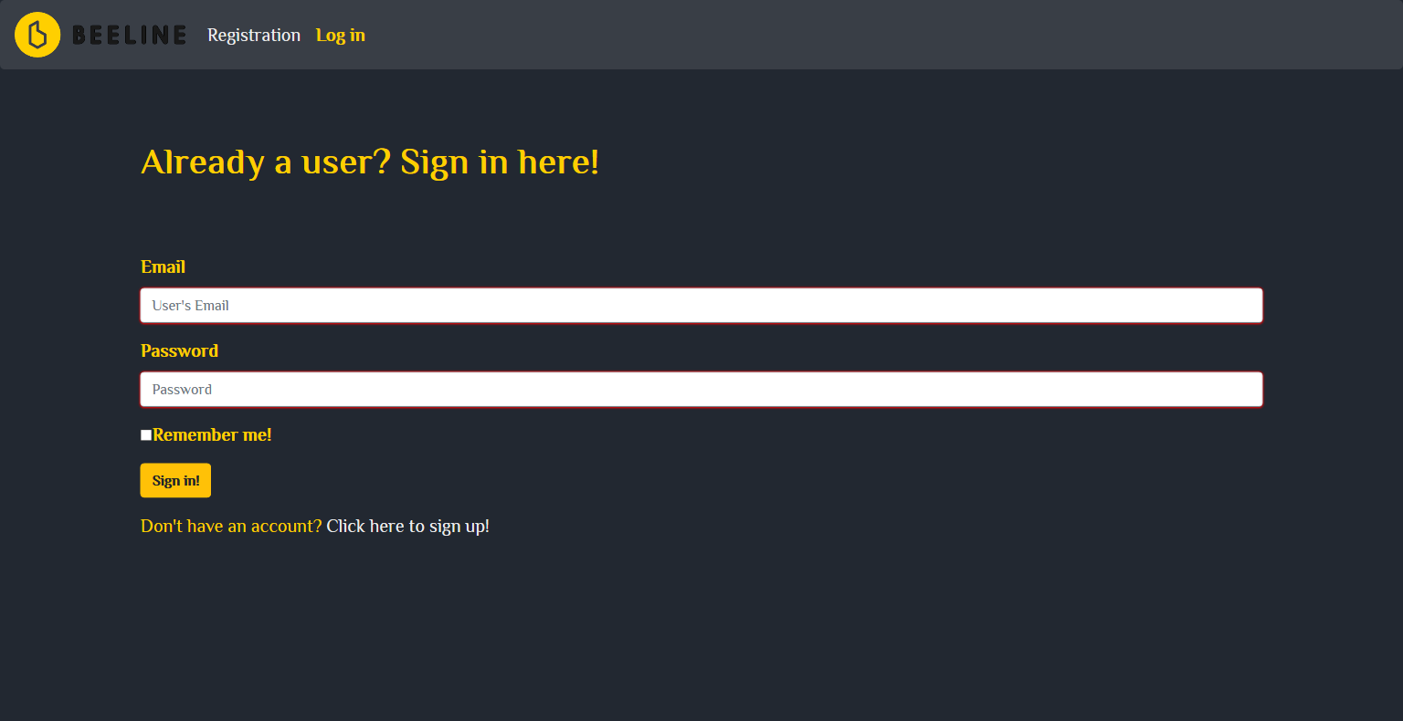

Map app:

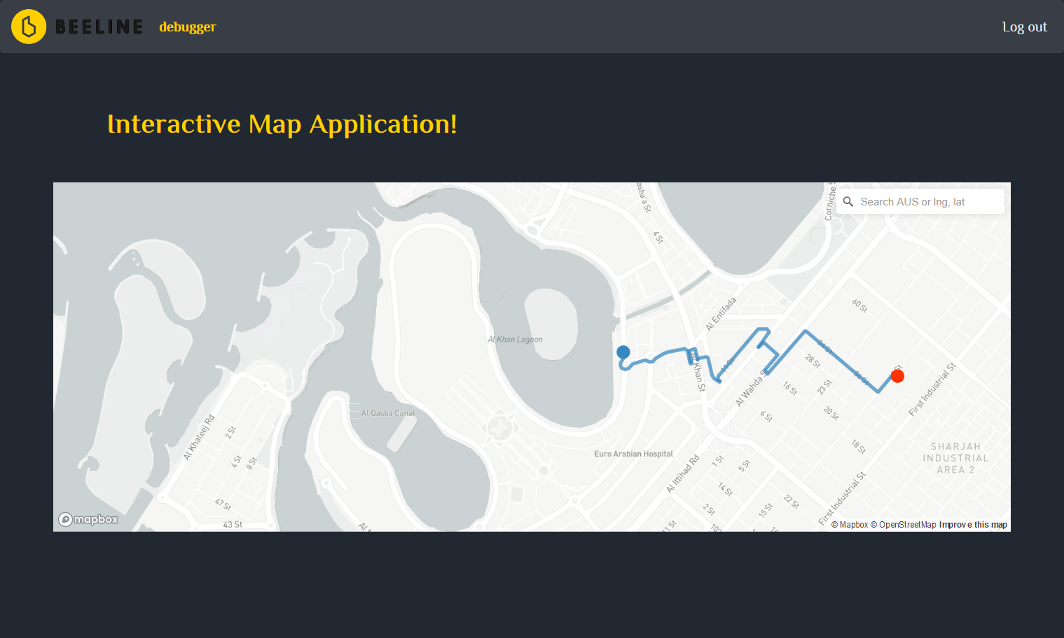

N+1 logins:

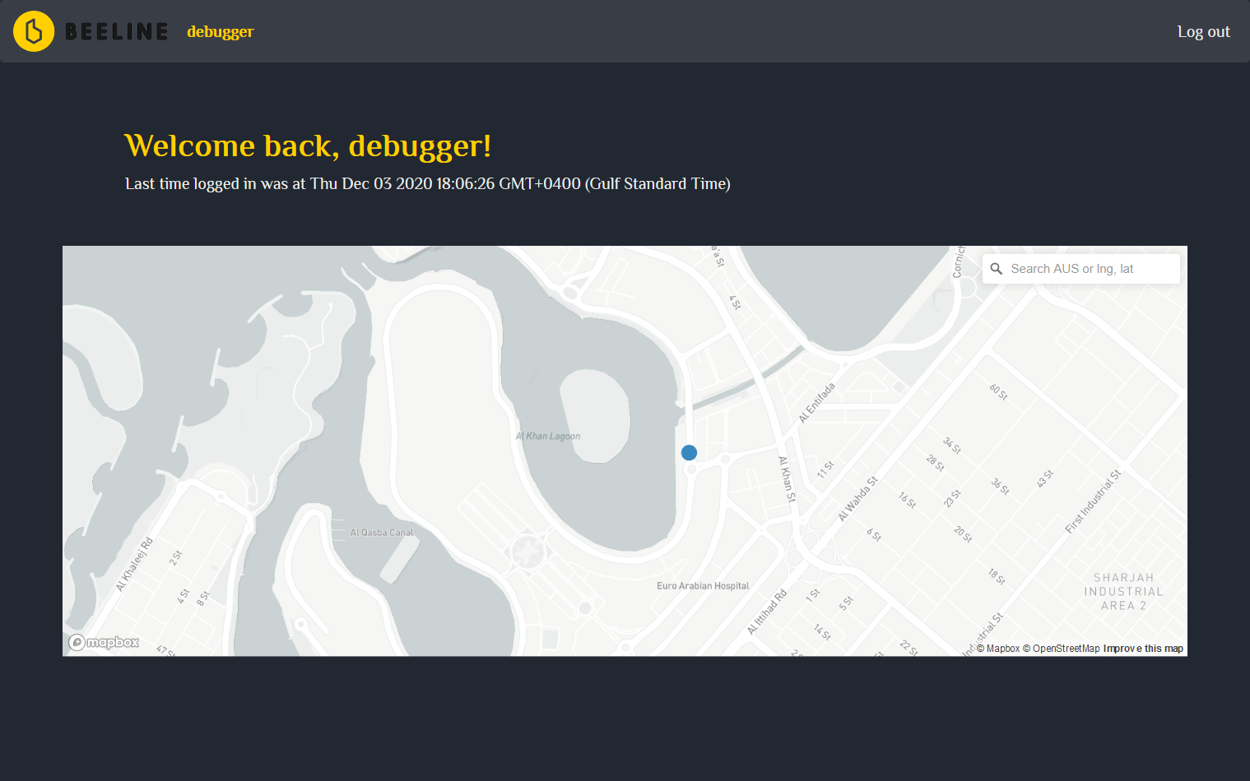

After clicking on logout the user gets redirected to the login page:



After that the user needs to login or else the user will be receiving an internal server error (500)

Moto device:

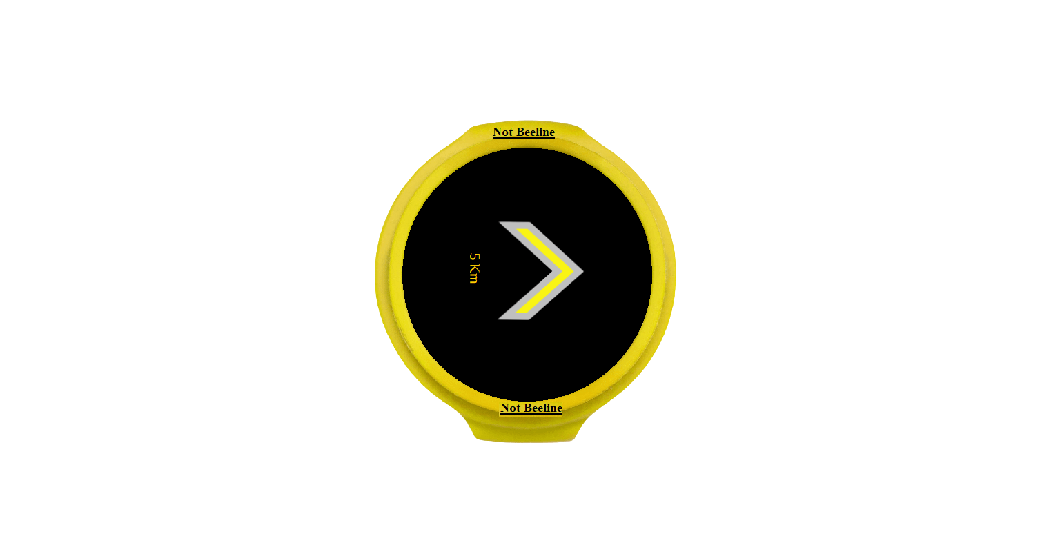

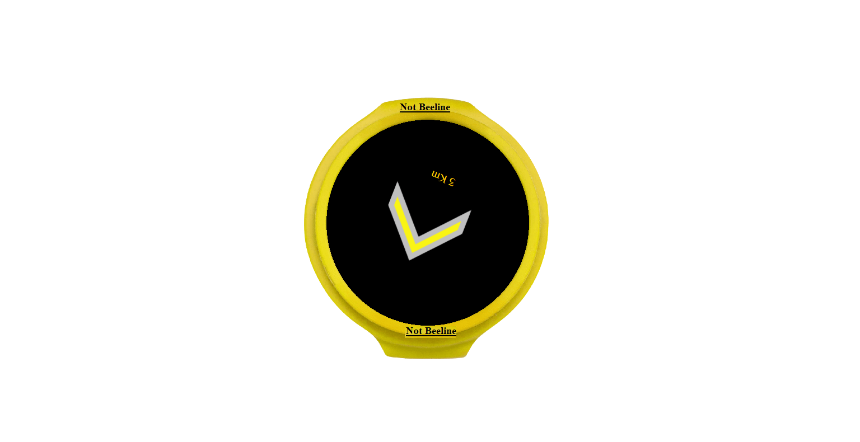

DB:

